Here we are created branch and checkout into that branch

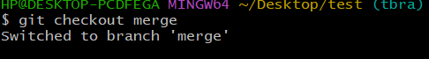

We are created merge.txt filewith some data using echo



Added merge.txt file



Checking status

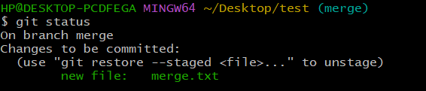

Commited that file

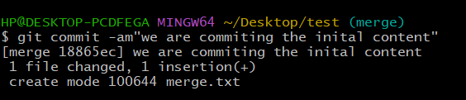

Created second branch and checkout into that branch

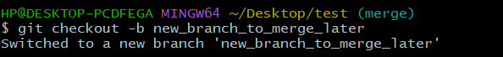

We are created merge.txt file with some data using echo



Commited that file

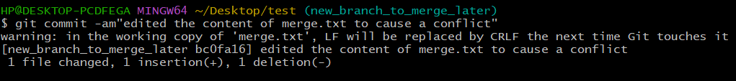

Now checkout into 1s branh (Merge)

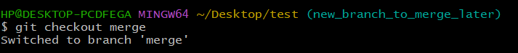

Override merge.txt 

Commit that file again

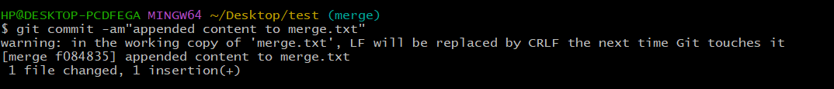

Now merge the 2nd branch with 1st branch

Check conflicts are arrived

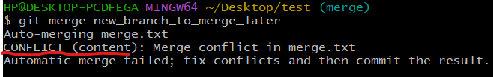

By using vi editor we can manually edit the file and remove the headers and footers



Add that file

And also commit that file 